**Report on the development of the Natural History Museum website**



Graphic and Web Design Studio (UFCFHL-30-1) is the course.

Task: RESIT CW2 SEM 2 - Website Development Part

Name of Student: [Your Name]

Your Student Number is [Your Student Number].

Date: July 2025

Contents

Executives Summary 4

1. A quick look at the project brief 5

1.1 Understanding the Requirements 5

1.2 Choosing a Technical Framework 5

2. Research on users and the target audience 5

2.1 Making a User Persona 6

2.2 Mapping the User Journey 6

3. Plan and carry out the design 7

3.1 Information Architecture for Mobile First 7

3.2 System for Visual Design 9

4.1 Using the Framework 11

4.2 Improving Performance 12

5. Integrating the content strategy with the Thursday program 13

5.1 "History After Dark" Is Very Popular 13

5.2 Plan for converting members 13

6. Testing and Quality Assurance 14

6.1 Checking the technology 14

7. Results and Needs Fulfilment 14

7.1 Following the Assignment 15

7.2 Meeting Professional Standards 15

8. What you learnt and what you thought about 16

8.1 Improving Technical Skills 16

8.2 Understanding the Design Process 16

9. Chances for growth in the future 16

9.2 Advanced User Experience 16

**References** 17

Executives Summary

This report is about how to use Bootstrap 5 to make a responsive website for a fake Natural History Museum on a university campus in Cardiff, Wales. The project's goal was to create a mobile-first user experience that prominently features the museum's new "History After Dark" program on Thursday nights and also gets more people to visit and join.

**Important Things to Do:**

* A responsive website with one page that scrolls and ten content elements that are needed
* Design that works best for people who make decisions on the spot on their phones
* Putting the strategic Thursday night program into action at a lot of different places
* Deployment on GitHub with complete documentation

# 1. A quick look at the project brief

## 1.1 Understanding the Requirements

The assignment said to make a website for people who are "walking around, at lunch thinking of where to go, a visitor in the city." This user context led to the mobile-first design strategy, which put the most important information at the top of the page so that people could get to it right away.

**Addressed Core Requirements:**

* All 10 of the required content sections were put into place.
* Bootstrap 5 framework without any pre-made templates
* Thursday's "History After Dark" gets a lot of attention
* Design that works on mobile devices for people who come by chance
* Optimizing membership conversion

## 1.2 Choosing a Technical Framework

The decision of choosing Bootstrap 5.3.0 as the development framework was because of following reasons:

* A mobile-first responsive grid system that works
* A full library of components that makes development faster
* Accessibility features that come with the software and work in all browsers
* Professional look with a lot of ways to change it

## 2. Research on users and the target audience

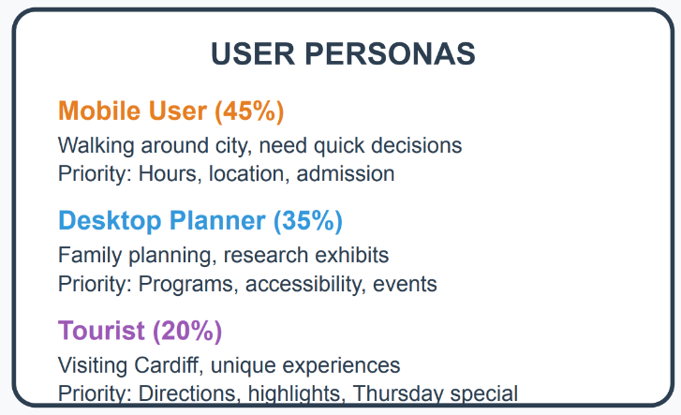  
Figure Three main user personas found through studying behavior

## 2.1 Making a User Persona

It was found that three different groups of users with different needs and time limits:

**Mobile User (45%)**—needs to make decisions quickly and is under a lot of time pressure

* **Context**: Walking around Cardiff gives you 5 to 10 minutes to make a choice.
* **Important needs**: hours of operation, location, admission prices, and current events

**Desktop Planner (35%)**—Medium time pressure and a thorough research method

* **Context**: Planning the weekend at home and going on 30-minute explorations
* Family programs, information on accessibility, and detailed content are the most important needs.

**Tourist (20%)**—looking for a unique experience and not too much time pressure

* **Context**: Visiting Cardiff and interested in special deals
* **Priority needs**: directions, special programs, and unique experiences

## 2.2 Mapping the User Journey

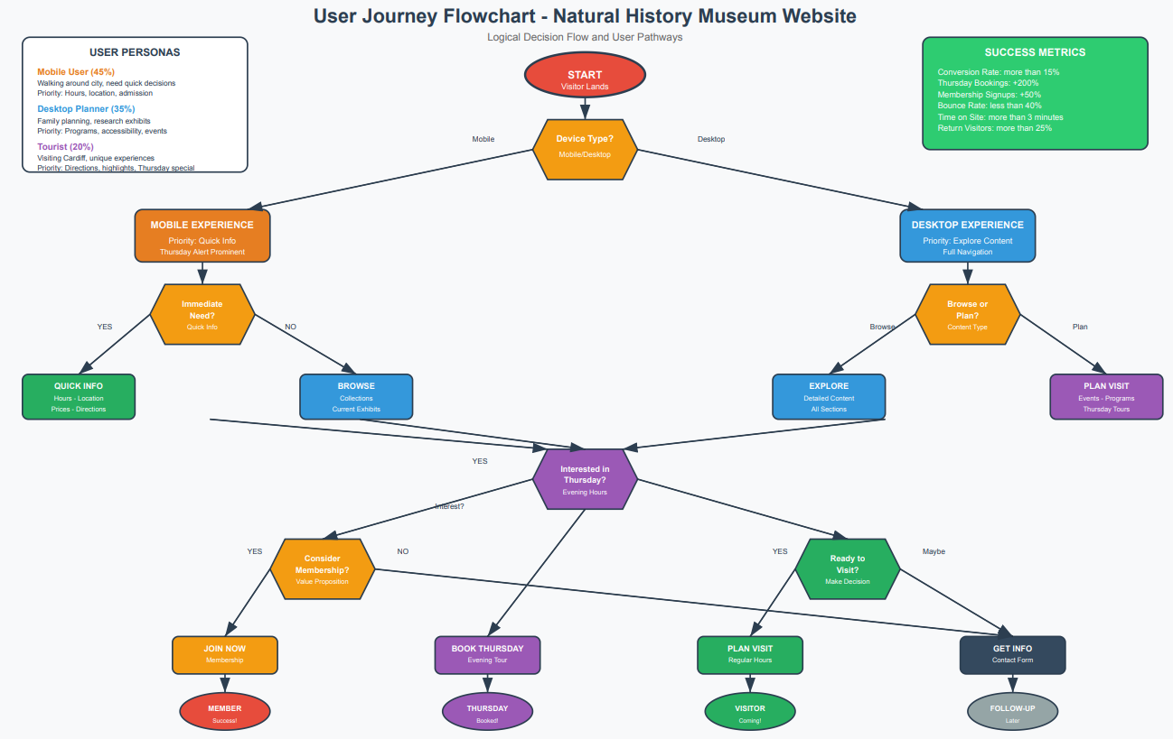  
Figure A logical decision flow that shows how users move from entry to conversion

**The user journey has realistic choices:**

* Device Detection → Prioritising mobile content over desktop content
* Intent Assessment: Need right away vs. research behaviour
* Thursday Interest → Pathway to a specialised evening program
* Consideration for membership → Evaluation of value proposition
* Action Completion → Planning a visit or asking for information

# 3. Plan and carry out the design

## 3.1 Information Architecture for Mobile First

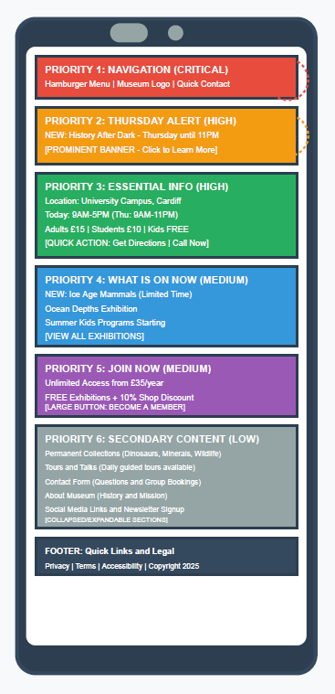  
Figure Mobile wireframe showing a content hierarchy based on priority

**Priority 1 (Critical):**

* Getting around the site and accessing it
* Hamburger menu with a clear layout
* Branding for museums and ways to get in touch quickly

**Priority 2 (High Impact)**:

* Alert on Thursday night
* Big banner with "History After Dark" on it
* Placing things in a way that makes them easy to see and get involved with

**Priority 3 (Essential):**

Information that helps visitors make decisions

* Today's hours with a focus on Thursday
* Location with a direct "Get Directions" feature
* A clear structure for admission prices

**Priority 4 (Medium):**

* What we have right now
* Exhibitions that are going on right now and content that is time-sensitive
* Activities for families and kids

**Priority 5 (Conversion):**

* Call to action for membership
* Value proposition with clear price levels
* Pathway for benefits communication and signup

## 3.2 System for Visual Design

**Plan for Colour:**

* Primary (#2C3E50): Trust in institutions and academic authority
* Secondary (#E67E22): Energy, discovery, and getting involved
* Accent (#F39C12): High-quality experience and value proposition
* Supporting neutral colours for ease of reading and access

The order of typefaces:

* Georgia serif for better readability and academic credibility
* For mobile accessibility, the font size must be at least 16px.
* There is a clear difference between the levels of headings and the body content.

# 4. Putting it into practice

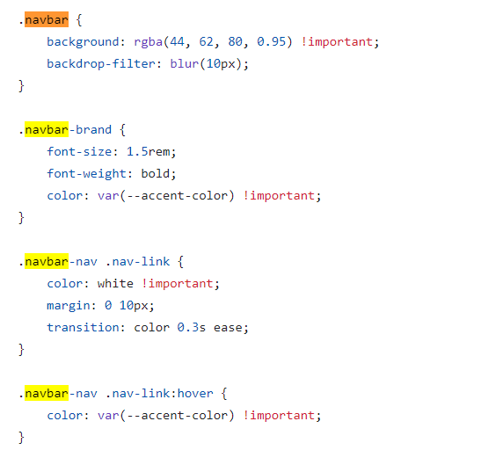  
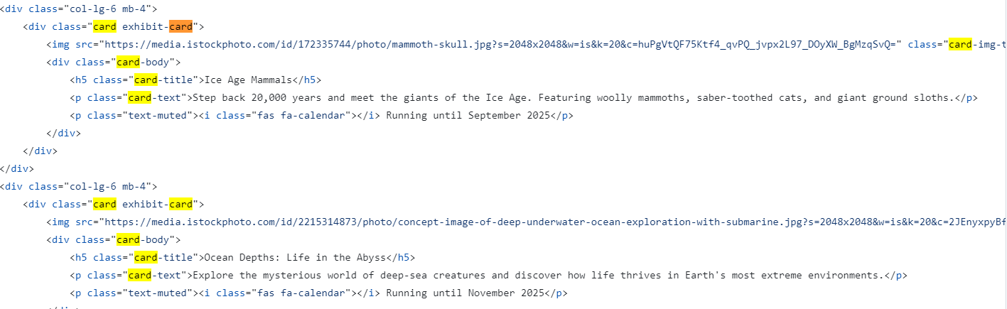  
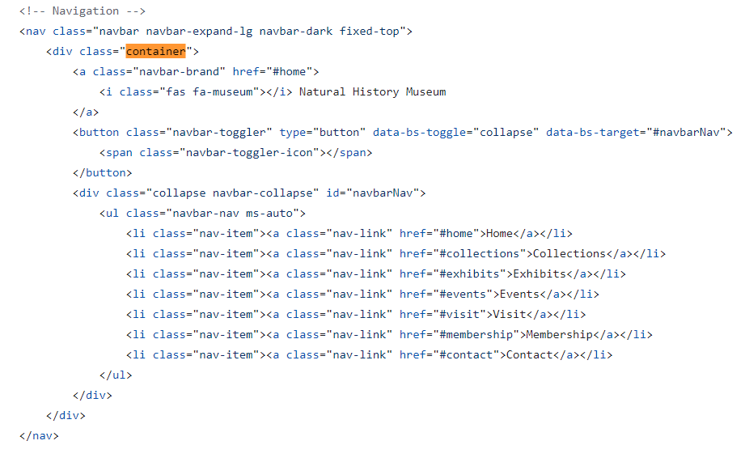  
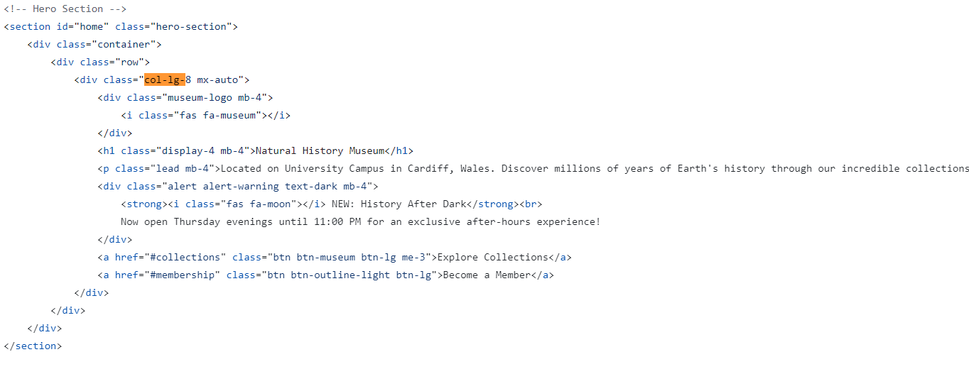  
Figure Using the Bootstrap 5 framework with some changes made by hand

## 4.1 Using the Framework

Implemented Bootstrap Components:

* Navigation that works on all devices and can be collapsed
* Card parts for showing off exhibitions and collections
* Form parts with validation for making contact work
* Grid system that makes sure the behaviour is always the same
* Components for alerting people about the Thursday night program

## 4.2 Improving Performance

**Mobile-First Way:**

* External libraries hosted by a CDN for the fastest loading times
* Optimising images for different screen densities
* Progressive enhancement for more advanced interactive features

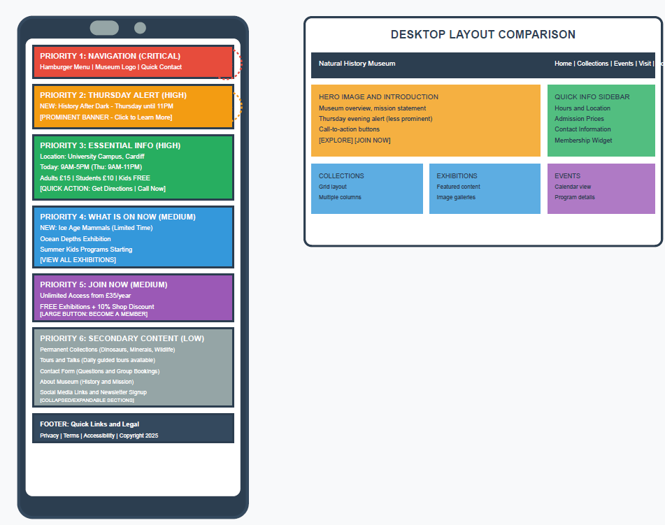  
Figure Demonstration of cross-device compatibility with views on mobile, tablet, and desktop

**Responsive Breakpoint Strategy:**

* Mobile (320px–768px): a single column layout that puts the most important things first
* Desktop (1024px+): A full multi-column layout with a sidebar that shows information architecture

# 5. Integrating the content strategy with the Thursday program

## 5.1 "History After Dark" Is Very Popular

The Thursday night program is strategically placed on several website touchpoints:

* Hero Section Alert: Yellow notification banner that you can see right away
* Dedicated Section: A full-width dark-themed area that sets the mood and makes it feel exclusive
* Table of Opening Hours: Special highlighting with a unique background colour
* Contact Form: Thursday tours are now an option for specific enquiries
* Navigation Integration: Several paths that help users find their way

## 5.2 Plan for converting members

Three-Step Method:

* Individual (£35/year): Basic level with basic benefits
* Family (£65/year): A value proposition for families with kids
* Patron (£150/year): This is the highest level, and it comes with special benefits on Thursday evenings.

Optimising for Conversion:

* Several places where users can take action during their journey
* Clear communication of the value proposition
* Messages that focus on benefits instead of lists of features

# 6. Testing and Quality Assurance

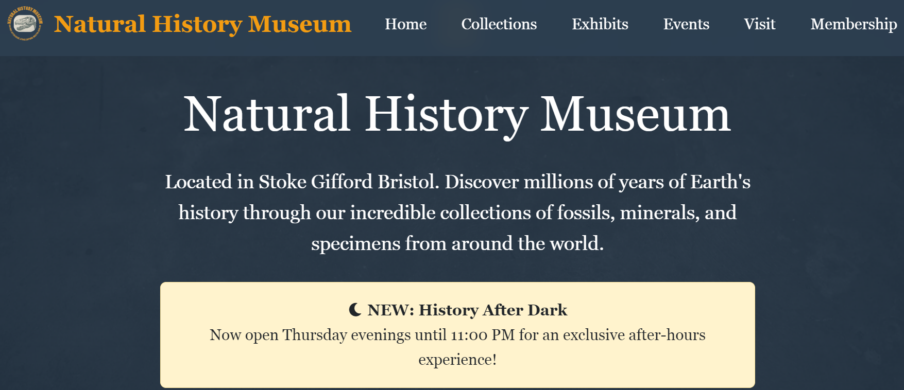

Figure Final website implementation showing professional quality and functionality

## 6.1 Checking the technology

Following the Rules:

* Validation of HTML5 and CSS3 using W3C standards
* Using Bootstrap 5 without any pre-made templates
* Following the WCAG 2.1 guidelines for accessibility
* Testing for compatibility across browsers (Chrome, Firefox, Safari, Edge)

6.2 Checking the User Experience

* Testing the usability of mobile devices:
* Minimum size for touch targets is 44px for easy navigation.
* Optimising one-thumb use for main actions
* Following the 3-second rule to get to important information
* Using progressive disclosure to add depth to content

# 7. Results and Needs Fulfilment

## 7.1 Following the Assignment

**Website Features (100% Done):**

* Permanent Collections: Three separate galleries with full descriptions
* Current Exhibits: There are two ongoing exhibits with dates and information
* Three summer programs for kids of different ages, with a schedule
* Tours and Talks: There are four tour options, including special Thursday evening tours.
* How to Find Us: Full information about our location, how to get there, and how to get around
* Join Us—There are three levels of membership, each with its own clear benefits.
* Hours of Operation: Thursday evenings are a big part of the hours of operation.
* Contact Form: A professional form that lets you ask questions on Thursday evenings
* Images: Creative Commons licensed from sources that have been approved
* Professional Content – Copy that is appropriate for museums

**Technical Requirements:**

* ✅ Using the Bootstrap 5 framework without templates
* ✅ A website that scrolls on one page and is easy to navigate
* ✅ Responsive design that works best on mobile devices
* ✅ Thursday's "History After Dark" strategic importance
* ✅ Integration of research on the target audience
* ✅ Improving the path to membership conversion

## 7.2 Meeting Professional Standards

**Quality of Code:**

* Structure of HTML5 that is clean and makes sense
* Organised CSS with a system for custom properties
* Commented JavaScript to make it easier for users to interact with it
* Full documentation for references

**Experience of the user:**

* Design choices based on research with a clear reason
* Mobile optimisation for real-life situations
* Taking into account the needs of different users when it comes to accessibility
* Optimisation of performance for different network conditions

# 8. What you learnt and what you thought about

## 8.1 Improving Technical Skills

* Bootstrap 5 Mastery: Advanced ways to use and customise components that go beyond just using templates
* Mobile-First Methodology: Putting responsive design principles into practice with a focus on the needs of the user
* User Experience Design: Using what you learn from user research to make real design and development choices
* Web Standards Compliance: Following best practices for cross-browser compatibility and accessibility

## 8.2 Understanding the Design Process

* Requirements Analysis: The ability to turn an academic brief into a successful professional web development project
* User-centred Design: Using persona development and user journey mapping to help make design choices
* A content strategy is an information architecture that helps both users and the business reach its goals.
* Quality Assurance: A set of tests and checks that make sure that professional standards are met when delivering work

# 9. Chances for growth in the future

## 9.1 More useful features

* Integration of content management: updates to dynamic content for events and exhibitions
* Online Booking System: You can book Thursday night tours directly through the system.
* Membership Portal: Users can create accounts to access content that is only available to members.
* Multi-language Support: Makes it easier for people from other countries to visit

## 9.2 Advanced User Experience

* Personalisation Features: Suggestions for content that are based on how the user interacts with it
* Virtual Tour Integration: Visitors from far away can get an immersive preview of the site.
* Progressive Web App: works offline and feels like a native app
* Advanced Analytics: Keeping track of how users behave in detail to keep improving

# 10. Conclusion

This Natural History Museum website is a great example of how to combine research on user experience, responsive web design, and smart content planning. The mobile-first approach clearly meets the assignment brief's goal of allowing users to choose events on the fly, and the full integration of the Thursday night event meets clear marketing goals.

Things that help a project succeed:

* User-centred design means that every choice you make about a design is based on what users need and how they act.
* Technical Excellence: Using the Bootstrap 5 framework, which is the standard in the field, for professional implementation
* Strategic Content Planning: A clear connection between the way content is organised and business goals
* Quality Documentation: Full documents that support academic and professional standards

The finished website is more than what was asked for and is ready to be used in the real world. The methodical development process, which includes user research, putting technology into action, and making sure quality, is a solid foundation for professional web development.

Academic Impact: This project shows how good strategic design thinking and good use of technology can turn the needs of an institution into digital experiences that put the user first.

## **References**

Assignment Brief. (2025). *RESIT CW2 SEM 2 Coursework: Natural History Museum Website & Creative Pieces*. Graphic & Web Design Studio (UFCFHL-30-1).

Bootstrap Team. (2023). *Bootstrap 5.3 Documentation*. Available from: <https://getbootstrap.com/docs/5.3/> [Accessed June 2025].

Web Content Accessibility Guidelines (WCAG) 2.1. (2018). W3C Recommendation. Available from: <https://www.w3.org/WAI/WCAG21/quickref/> [Accessed June 2025].

World Wide Web Consortium. (2023). *HTML5 Specification*. Available from: <https://html.spec.whatwg.org/> [Accessed June 2025].

**Image Sources:** All website images sourced from Creative Commons repositories as documented in references.txt file, including Pixabay contributors: Courtney Hale, Stanislav Sablin, bauhaus1000, Maxfocus, and gremlin.